Experiment No.1

Date: 30-01-2025

Aim: Fundamentals of Java Programming in IntelliJ IDE

CO Mapping – CO 1

Objective:

* To understand declaration of Classes, and Methods with its all features such as Constructors, Access Specifier
* To understandClasses, Instance variables, Methods, Constructors, Access
* Specifiers as basic fundamentals
* Implement Abstract Classes and Wrapper Classes for given problem statement
* Design and implement Inheritance, Polymorphism inJAVA
* Demonstrate Use of Static, final, super and this keyword
* Demonstrate creating user defined package, Access controlprotection,
* Defining interface, Implementing interface

Lab Exercise:

Implement code for

1. biggest of Three numbers.
2. Grade wise Result by taking Students Marks.
3. Calculator.
4. Employ Salary hourlyBasis and monthlyBasis.
5. Bank Function like Withdraw and Deposite

* **Biggest of Three numbers.**

**Code**import java.util.Scanner;  
  
public class BiggestOfThree {  
  
 public static void main(String[] args) {  
 Scanner sc = new Scanner(System.*in*);  
  
   
 System.*out*.println("\n*Biggest of Three*");  
 System.*out*.println("Enter value of num 1: ");  
 int num1 = sc.nextInt();  
 System.*out*.println("Enter value of num 2: ");  
 int num2 = sc.nextInt();  
 System.*out*.println("Enter value of num 3: ");  
 int num3 = sc.nextInt();  
  
 BiggestOfThree biggest = new BiggestOfThree();  
 biggest.findBiggest(num1, num2, num3);  
 }  
 public void findBiggest(int num1, int num2, int num3) {  
 if (num1 > num2 && num1 > num3)  
 System.*out*.println("Num 1 is greater");  
 else if (num2 > num1 && num2 > num3)  
 System.*out*.println("Num 2 is greater");  
 else  
 System.*out*.println("Num 3 is greater");  
 }  
  
}

**Outputs:**

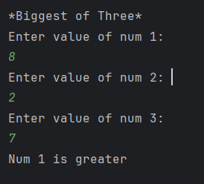

* **Biggest of Three numbers.**

**Code**

import java.util.Scanner;  
  
public class Result {  
  
 public static void main(String[] args) {  
 Scanner sc = new Scanner(System.*in*);  
  
 System.*out*.println("\n*Result*");  
 Result result = new Result();  
 result.calculateResult(sc);  
 }  
 public void calculateResult(Scanner sc) {  
 System.*out*.println("\nEnter the Marks of the subject");  
  
 System.*out*.println("Enter the Marks of DAA subject: ");  
 int DAA = sc.nextInt();  
  
 System.*out*.println("Enter the Marks of DevOps subject: ");  
 int DevOps = sc.nextInt();  
  
 System.*out*.println("Enter the Marks of AJP subject: ");  
 int AJP = sc.nextInt();  
  
 System.*out*.println("Enter the Marks of MP subject: ");  
 int MP = sc.nextInt();  
  
 System.*out*.println("Enter the Marks of PA subject: ");  
 int PA = sc.nextInt();  
  
 System.*out*.println("Enter the Marks of PCS subject: ");  
 int PCS = sc.nextInt();  
  
 System.*out*.println("Enter the Marks of PNS subject: ");  
 int PNS = sc.nextInt();  
  
 int avg = (DAA + DevOps + AJP + MP + PA + PCS + PNS) / 7;  
  
 System.*out*.println("Percentage of the student is: " + avg);  
  
 if (avg >= 90)  
 System.*out*.println("The Student got Grade A+");  
 else if (avg >= 80)  
 System.*out*.println("The Student got Grade A");  
 else if (avg >= 70)  
 System.*out*.println("The Student got Grade B+");  
 else if (avg >= 60)  
 System.*out*.println("The Student got Grade B");  
 else if (avg >= 50)  
 System.*out*.println("The Student got Grade C");  
 else if (avg >= 35)  
 System.*out*.println("The Student got Grade D");  
 else  
 System.*out*.println("The Student got Grade F");  
 }  
}

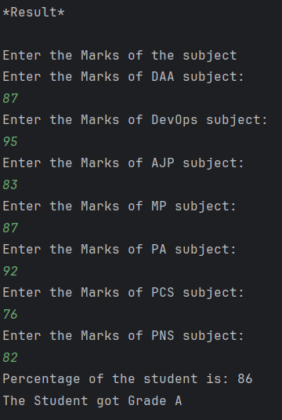**Outputs:**

* **Calculator**

**Code:**

import java.util.Scanner;  
public class Calculator  
{  
 public static void main(String[] args) {  
 Scanner sc = new Scanner(System.*in*);  
 System.*out*.println("\n*Calculator*");  
 Calculator.*performCalculator*(sc);  
 }  
 public static void performCalculator(Scanner sc) {  
 int num1, num2, choice;  
  
 System.*out*.println("Enter the value for 1st Number: ");  
 num1 = sc.nextInt();  
  
 System.*out*.println("Enter the value for 2nd Number: ");  
 num2 = sc.nextInt();  
  
 do {  
 System.*out*.println("\nMenu:");  
 System.*out*.println("1. Addition");  
 System.*out*.println("2. Subtraction");  
 System.*out*.println("3. Multiplication");  
 System.*out*.println("4. Division");  
 System.*out*.println("5. ReEnter the Numbers");  
 System.*out*.println("6. Exit");  
  
 System.*out*.print("Enter your choice: ");  
 choice = sc.nextInt();  
  
 if (choice >= 1 && choice <= 4) {  
 *performCalculation*(num1, num2, choice);  
 } else if (choice == 5) {  
 *assignNumbers*(sc);  
 } else if (choice == 6) {  
 System.*out*.println("Exiting the program. Goodbye!");  
 } else {  
 System.*out*.println("Invalid choice! Please try again.");  
 }  
  
 } while (choice != 6);  
 }  
  
 public static void assignNumbers(Scanner sc) {  
 System.*out*.println("Enter the value for 1st Number: ");  
 int num1 = sc.nextInt();  
  
 System.*out*.println("Enter the value for 2nd Number: ");  
 int num2 = sc.nextInt();  
 }  
  
 public static void performCalculation(int a, int b, int choice) {  
 switch (choice) {  
 case 1:  
 *addition*(a, b);  
 break;  
 case 2:  
 *subtraction*(a, b);  
 break;  
 case 3:  
 *multiplication*(a, b);  
 break;  
 case 4:  
 *division*(a, b);  
 break;  
 }  
 }  
  
 public static void addition(int a, int b) {  
 int sum = a + b;  
 System.*out*.println("The result of Addition is: " + sum);  
 }  
  
 public static void subtraction(int a, int b) {  
 int sub = a - b;  
 System.*out*.println("The result of Subtraction is: " + sub);  
 }  
  
 public static void multiplication(int a, int b) {  
 int mul = a * b;  
 System.*out*.println("The result of Multiplication is: " + mul);  
 }  
  
 public static void division(int a, int b) {  
 if (b == 0) {  
 System.*out*.println("Error: Division by zero is not allowed.");  
 } else {  
 float div = (float) a / b;  
 System.*out*.println("The result of Division is: " + div);  
 }  
 }  
}

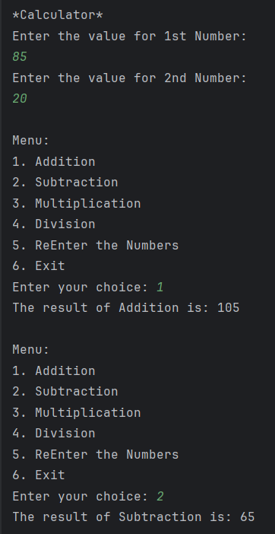**Outputs:**

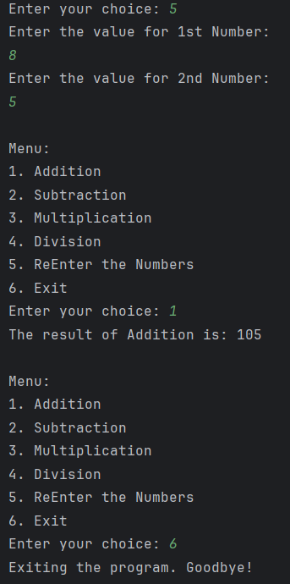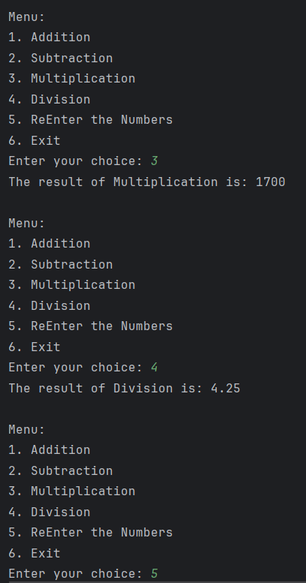

* **Employ Salary hourlyBasis and monthlyBasis**

**Code:**

class employee {  
 private int employeeNumber;  
 private String employeeName;  
 protected int salary;  
  
 public void getData(int empno, String empname) {  
 employeeNumber = empno;  
 employeeName = empname;  
 }  
  
 public void putData() {  
 System.*out*.println("Employee Number: " + employeeNumber);  
 System.*out*.println("Employee Name: " + employeeName);  
 System.*out*.println("Employee Salary: " + salary);  
 }  
  
 public static void main(String[] args) {  
 // Hourly Basis Employee  
 System.*out*.println("\n*Hourly Basis Employee*");  
 hourlyBasis hourlyBasisEmployee = new hourlyBasis();  
 hourlyBasisEmployee.getData(1, "Atharva");  
 hourlyBasisEmployee.getHourlyData(1, 800);  
 hourlyBasisEmployee.calculate();  
 System.*out*.println("Hourly Basis Employee Details:");  
 hourlyBasisEmployee.putData();  
  
 // Monthly Basis Employee  
 System.*out*.println("\n*Monthly Basis Employee*");  
 monthlyBasis monthlyBasisEmployee = new monthlyBasis();  
 monthlyBasisEmployee.getData(2, "Adam");  
 monthlyBasisEmployee.getMonthlyData(15000, 10, 1);  
 monthlyBasisEmployee.calculate();  
 System.*out*.println("\nMonthly Basis Employee Details:");  
 monthlyBasisEmployee.putData();  
 }  
}  
  
class hourlyBasis extends employee {  
 private int hours;  
 private int rate;  
  
 public void getHourlyData(int h, int r) {  
 hours = h;  
 rate = r;  
 }  
  
 public void calculate() {  
 salary = hours * rate;  
 }  
}  
  
class monthlyBasis extends employee {  
 private int basic;  
 private int hra;  
 private int da;  
  
 public void getMonthlyData(int b, int h, int d) {  
 basic = b;  
 hra = h;  
 da = d;  
 }  
  
 public void calculate() {  
 salary = basic + (basic * hra / 100) + (basic * da / 100);  
 }  
  
}

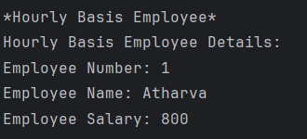**Outputs:**

* 
* **Bank Function like Withdraw and Deposite**

import java.util.Scanner;  
  
public class bank {  
 public static void main(String[] args) {  
 Scanner sc = new Scanner(System.*in*);  
  
 Account acc = new Account(1, "Atharva", 1000);  
  
 boolean breakFlow;  
 do {  
 System.*out*.println("\nBank Menu");  
 System.*out*.println("1. Deposit");  
 System.*out*.println("2. Withdraw");  
 System.*out*.println("3. Check Balance");  
 System.*out*.println("4. Exit");  
 System.*out*.print("Enter your choice: ");  
  
 int choice = sc.nextInt();  
 breakFlow = true;  
  
 switch (choice) {  
 case 1:  
 System.*out*.print("Enter amount to deposit: ");  
 double depositAmount = sc.nextDouble();  
 acc.deposit(depositAmount);  
 break;  
 case 2:  
 System.*out*.print("Enter amount to withdraw: ");  
 double withdrawAmount = sc.nextDouble();  
 acc.withdraw(withdrawAmount);  
 break;  
 case 3:  
 acc.checkBalance();  
 break;  
 case 4:  
 System.*out*.println("Thank you for using the bank. Goodbye!");  
 breakFlow = false;  
 break;  
 default:  
 System.*out*.println("Invalid choice. Please enter proper value.");  
 }  
 } while (breakFlow);  
 }  
 static class Account {  
 private int accNumber;  
 private String name;  
 private double balance;  
  
 public Account(int accNumber, String name, double initialBalance) {  
 this.accNumber = accNumber;  
 this.name = name;  
 this.balance = initialBalance;  
 }  
  
 void withdraw(double amount) {  
 if (amount > balance) {  
 System.*out*.println("You have insufficient balance.");  
 } else {  
 balance -= amount;  
 System.*out*.println("Debited " + amount + " from your account.");  
 System.*out*.println("Your current balance is: " + balance);  
 }  
 }  
  
 void deposit(double amount) {  
 balance += amount;  
 System.*out*.println("Credited " + amount + " to your account.");  
 System.*out*.println("Your current balance is: " + balance);  
 }  
  
 void checkBalance() {  
 System.*out*.println("Your current balance is: " + balance);  
 }  
 }  
}

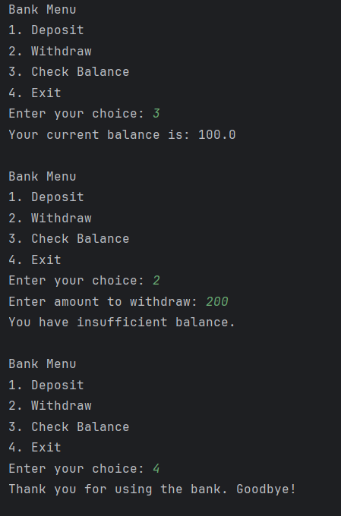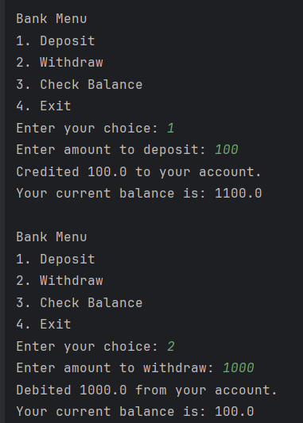**Outputs:**

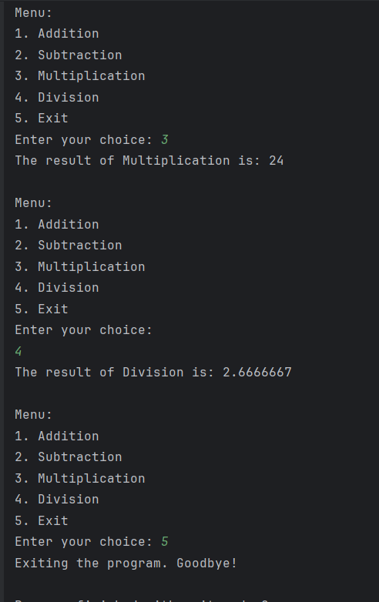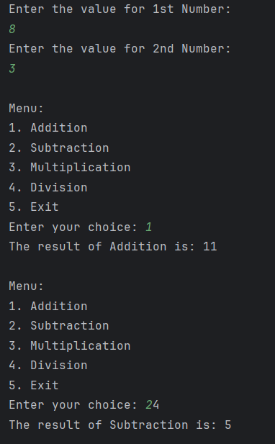

**Observation:**

This lab covered fundamental concepts of Object-Oriented Programming (OOP) in Java, such as classes, methods, constructors, and access specifiers. By implementing programs like finding the largest of three numbers, student grade calculation, and a basic calculator. Additionally, the exercises on employee salary calculation and banking functions helped to gain idea on the use of inheritance, polymorphism, and encapsulation.